ראייה ממוחשבת – תשפ"ד תרגיל בית 2

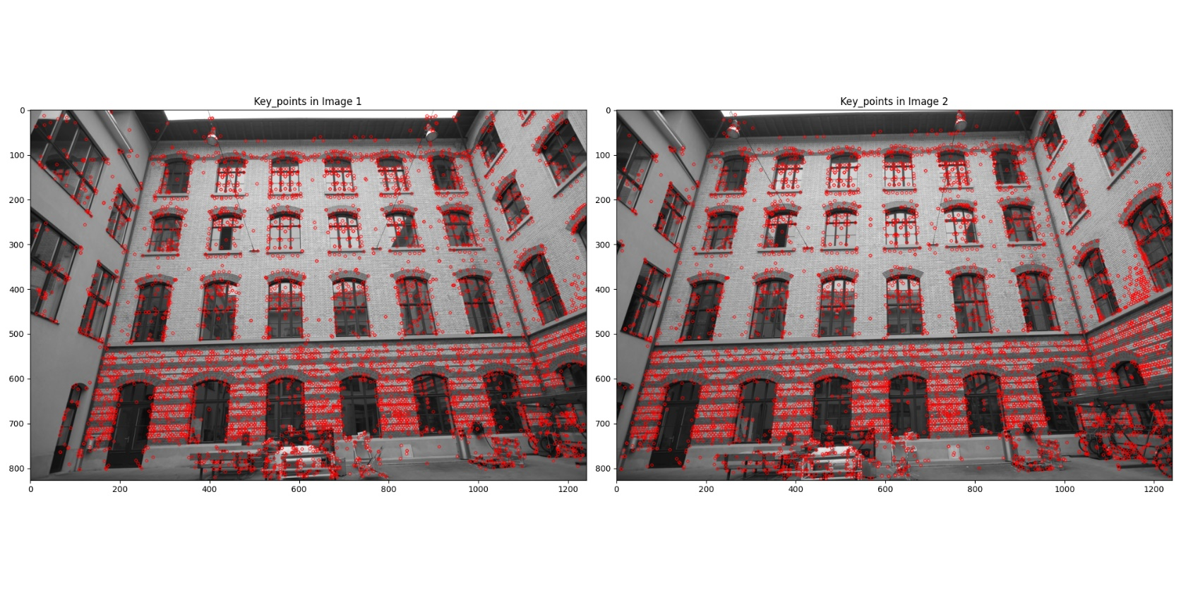1.

2.

3.



